2019 Rule Book Changes

102.1.1 Helmet Out of Compliance:
Any driver that is found out of compliance in a post-race inspection with rule and specifications listed above (102.1) will receive a 10-position penalty.

102.2 Neck Collar:
All classes except Senior must wear a Neck Collar as manufactured and shall not be altered in any way. If a driver does not have a neck collar on, loses their neck collar or it becomes loose while on track, they will be black flagged immediately.
Senior classes do NOT require a neck collar.
Advanced neck and head supports are highly recommended for drivers of all ages.
Approved devices include:
• Leatt-Brace Moto Kart and Moto GPX
• EVS Evolution Race Collar
• Valhalla 360 Plus Device

102.2.1 Neck Collar Out of Compliance:
Any driver that is found out of compliance in a post-race inspection with rule listed above will receive a 10-position penalty.

102.3 Chest & Rib Protectors:
All drivers under the age of 13 years in all divisions are required to wear a chest protection device with
SFI approved specification 20.1 at all times they are on the race track. The SFI tag must be attached to the chest protector.
The following chest protectors are approved and certified by SFI.

Group 6
3590 Pebble Beach Dr., Martinez, GA 30907
706-373-4515 www.group6gear.com 20.1/1, 20.1/2
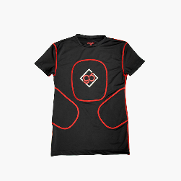
The chest pad Shall be in place while on track.

Ribtect
102 Holly Oak Court, Victoria, TX, 77901
(310) 487-8938 www.ribtect.com 20.1/1, 20.1/2

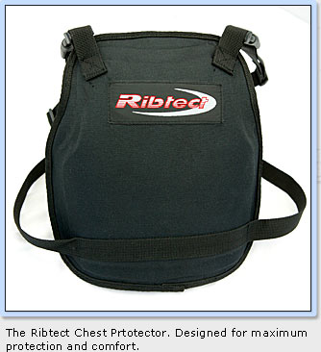

Team Valhalla
22227 F50, Stryker, OH, 43557
(419) 682-1360 www.valhallaracing.com 20.1/1, 20.1/2
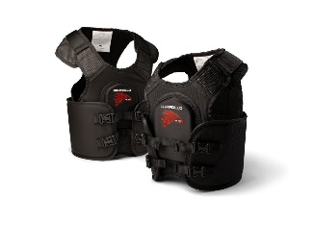
RECOMMENDED: The use of chest protection is recommended for all types and ages of kart drivers.

102.3.1 Chest Protector Out of Compliance:
Any driver that is found out of compliance in a post-race inspection with rule listed above will receive a 10-position penalty.

302.15 Practice:
Drivers will practice with their class. If a driver practices with another class without USPKS approval they will be penalized. Testing Monday thru Thursday the week of the event will not be permitted at the track at which the event will be held. Anyone violating this rule will not be allowed to practice on Friday. Furthermore, they must participate in qualifying on Saturday and Sunday and start at the back of both of the heat races or pre final on both days. Starting position for the finals will be based on the accumulated points they received from the heat races or pre final. Anything outside of a concession rental kart is not allowed.
** USPKS tracks may have practice on Thursday
afternoon, please check USPKS website and
Timeline for more information.

302.36 Data Acquisition:
Data acquisition systems can be used to retrieve any of the following: RPM, lap times, head temperature, exhaust temperature, water temperature, speed, pedal location, brake/master cylinder pressure, GPS tracking or computer scoring. Any telemetry, other sensors or inputs shall be removed or disconnected while kart is on track during official practice or race days. Data downloading can only be done in the pit area. Only one beacon for each type of system is allowed on the track and will be placed at the USPKS approved location. GPS systems are legal.

Route 66 Series Only:

402.11 IAME KA100 Masters:
Age: 30+ years old or 15+ if driver over 200lbs.
Engine: IAME KA100
Carburetor: HW-33A
Exhaust: IAME OEM KA100 Header & Pipe
Weight: 400 lbs.
Tires: Slicks MG “HZI” Red 4.60 Fronts & 7.10 Rears
Rains MG “WT” 4.20 Fronts & 6.00 Rears
* Qualify on new tires Sat. and run same tires on Sun.
* See Section 505 and Route 66 or USPKS Website for additional Engine Rules.

501.9 Cylinder Ports:
Must remain as manufactured. May be compared to a known stock part. No grinding, polishing, beveling, radiusing, chamfering, rounding or any deviation from the factory presentation will not be allowed. Noncompliance with stock or as manufactured includes any visible or measurable deviations. This may also include excessive wear that can be suspect of a performance enhancement.
506.12.2 Ignition Rotor & Key:
Ignition rotor key slot – 0.103” No-Go
Ignition key – 0.096” No-Go

